Probabilistic Analysis of False Positive Error Detection in Software Code

By Dmitri Ilkaev

Introduction

Code analysis and profiling with special tools has become a commodity in the processes of code design and development. There are a lot of commercial and open source tools for both Microsoft and Java worlds. New tools continue to come on the market while existing, established tools become more effective and robust. Some of these tools do only one of static or run time analysis; others are focused on only a few particular areas (optimization of structural analysis); still others will provide a full suite of offerings that perform all sorts of code reviews and analysis.
Among common problems in this area (for example; what is the best code analysis strategy and how to run the analysis, how to set up the best rule sets for the current project, how to separate small scale issues from large scale issues, where to allow automatic fixes and where to do them by hand), there is one particular irritation familiar to any engineer who had ever ran a code analyzer tool: false positives. False positives occur when a tool reports a defect where none actually exists. According to [1], in some situations the number of false positives may significantly exceed the number of the true defects discovered in the code. This paper presents a simple probabilistic approach to analysis of the false positive detection in the software code.

Approach

We assume that we know (or can estimate) the density of the software defects in the code. By software defects we intend a broad category that includes; syntax errors, type and format errors, access violation, etc. Since we are talking about defects detected by code analyzers, these defects can also belong to categories defined by a rule base configured within the tool, such as; compliance with the naming conventions, conformance to design patterns, performance optimization, etc.
Regardless of the defect origin, we define the probability of having software defects in the examined code as Pd. Thus, when we take a code sample (or even a single line of code) the probability of finding a defect will be Pd while the probability that the code is clean will be 1-Pd. Let’s now examine what happens when we apply our code analyzer to this code sample. A code analyzer, depending on how well it is engineered and the design principles and code detection algorithms that it manifests, will be able to find defects in the code also with some probability Pf. Obviously, the better the tool and more accurate the defined rule sets, the higher the value of Pf. Even so, when our code analyzer is against clean code, it will still generate some exceptions and will still point out some defects, the so called ‘false positive’ defect detection.
From this discussion, we can see that the whole procedure of code analysis and defect discovery can be represented by the flow shown below.

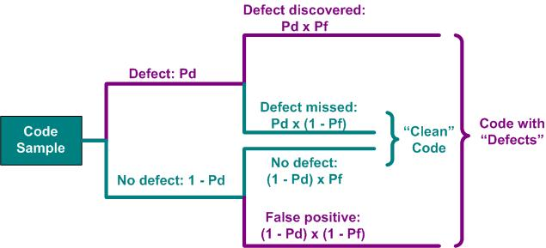

Figure 1. Flow of defects discovery by code analyzer

Using this flow diagram it’s easy to understand that when code analyzer is examining the code, the probability that this defect will be discovered is Pd x Pf while the probability that this defect will be missed is Pd x (1- Pf). At the same time when the code analyzer is looking at the defect-free parts of the code, the probability that it will confirm that the code is clean will be Pf x (1 – Pd) while the probability of false positive detection will be (1 – Pd) x (1 – Pf). This flow and its related probabilities reveal two formulas related to defect discovery.
When we are looking at the discovered defects, the probability that a defect is false positive can be calculated as:

Pfp = (1 – Pd) x (1 – Pf)/[ (1 – Pd) x (1 – Pf)+ Pd x Pf],

The ratio between false positive defects and real defects discovered in the code is:

R = (1 – Pd) x (1 – Pf)/(Pd x Pf)

Results and Discussion
For a working definition of defect density of software code we took the value of 1 defect per 1500 lines of code, see [2], which gives us the value of Pd = 0.00067. The following graphs show the probability (percentage) of false positives and their ratio to the number of real defects in relation to the accuracy of error detection by the code. Notice that we took a rather high accuracy of defect discovery by the tool, from 99.90% to 99.99%.

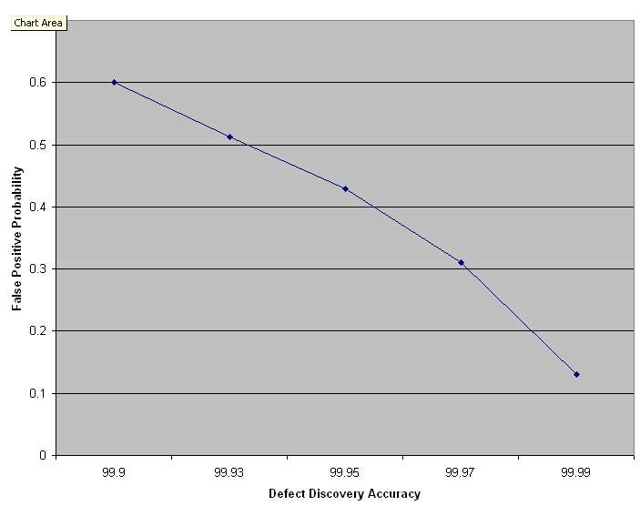

Figure 2 Probability (percentage) of false positive error detection

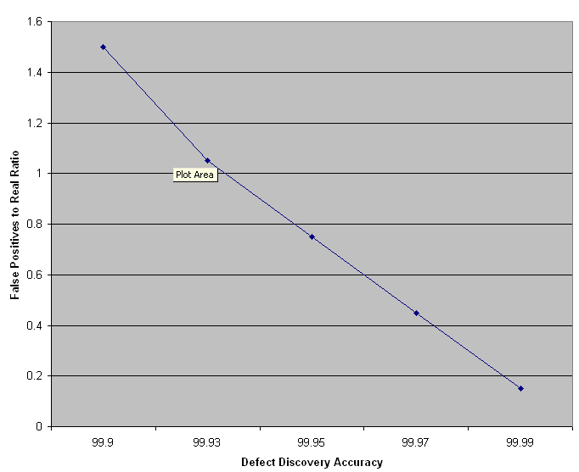

Figure 3 Ratio of False Positives to Real Defects

From dependencies and formulas we make an interesting conclusion: the number of false positives is quite high even when code analyzer detects errors with reasonable. Even with the 99.99% accuracy we have about 13% (one defect out of seven or eight found) from all discovered errors to be false positives, which seems in accordance with observed behavior: Coverity [3] describes their statistics as one false positive to four real defects, which corresponds well with the 99.985% accuracy in detection. When the error detection is low (90% or less) there will be an exceptionally high number of false positives reported against a single case of a real error, like in a situation described in [1]. We should note here, that the lower accuracy in error detection is not related to the quality of the code analyzer as a tool but is rather caused by uncertainty in setting up analysis rules and the exceptions to be captured by this tool. Another helpful observation is the fact that the high number of false positives is more typical for the high quality code. On the picture below we present the percentage of the false positives in dependence on the accuracy of the code analyzer for a much “buggier” software (1 defect per 150 lined of code, just increased the original defect density into ten times).
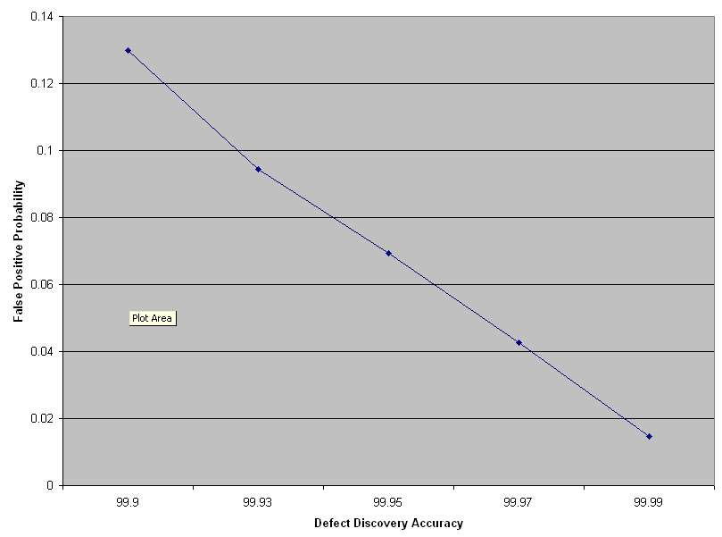

Figure 4. Probability (percentage) of false positive error detection. Defect density of 10 times higher than on Figure 2.

These results show us that for code with a higher defect density, a code analyzer does a better job detecting errors and produces a much smaller number of false positive detections (5-10 times reduction of false positives for a buggier software code). These interdependencies help to define a better approach to code profiling on the base of code analyzers. If we are after the typical set of errors in the code – it makes sense to run these tools at the early phases of development a higher density of bugs and fewer other rules configured. At this point we have a good chance of cleaning up the code significantly, leaving later phases to concentrate on the other aspects of the code quality such as, conformance to standards and naming conventions, design and performance optimization, etc. As we can add more rules to the analyzer, we need to be better prepared to handle an increase in false positive warnings (which will be less critical at this phase of the code cleanup).

Conclusion

We present a simple probabilistic model that describes the occurrence of false positive software defect detection by code analyzers. This model is based on the two parameters: initial defect density in the code, and the accuracy of defect detection by a code analyzer. The calculations performed based on this model show that a noticeable percentage of false positives is a normal fact for a typical automated code analysis process, and that this percentage is in a reverse relationship with the code quality: at a constant accuracy of code analysis and error detection, a higher defect density correlates to a lower number of false positives . Reduction in error detection accuracy results in a significant increase of false positives: since the accuracy depends mainly on the rule sets and compliance guidance defined in the tool, special attention should be paid to this configuration during later phases of code analysis. We believe that the described model and sample calculations will be helpful to software engineers during their work setting up the strategy and processes of automated code analysis.

References
[1]. Uprooting Software Defects at the Source Seth Hallem, David Park, Dawson Engler, Coverity http://www.acmqueue.com/modules.php?name=Content&pa=printer_friendly&pid=95&page=3

[2]. Automated Software Inspection Scott Trappe; Lawrence Markosian http://jdj.sys-con.com/read/36154.htm

[3]. http://www.spectrum-systems.com/coverity.htm

