


“ Best Practice ”
Profiling Framework

- Sunil Chacko

“ Profiling is only as good as you want it to be”

Abstract

This paper outlines the "Best Practice" that covers the essentials as well as the framework that the group has followed for Profiling the VoIP Call Manager.
Profiling any of the Media Convergence Servers (MCS) entails among other things, testing the performance of the Call Manager

We will explore the "Best Practice" strategy in detail that can be systematically employed in helping to achieve performance improvements. The paper has consciously been kept as generic as possible, so that it can be applied in any environment. The goal of effective performance testing is to ensure that the servers with the software will perform within acceptable performance levels, whatever those levels need to be.

This paradigm shift in the way information is delivered to devices will require new ways to test and tune applications for performance. Just as traditional platforms cannot keep pace with this shift in technology, traditional functional testing methodologies cannot adequately define application performance and identify bottlenecks associated with new applications. Hence, a new way of approaching the traditional software development life cycle, which includes effective performance testing throughout, is required.

We assume that our typical reader is responsible in some way for Performance testing on one or more Windows servers and that he or she has an interest in improving its performance as much as possible without deploying additional hardware (such as dedicated acceleration appliances) or services (such as Content Distribution Networks).

We will also suggest wherever possible, practical ways that will leverage common standards in order to maximize hardware and network resources, thus improving the application performance while lowering the total cost of ownership of the infrastructure.



Introduction

In a sea of change, computer performance is one of the few areas of computing to remain relatively constant. Performance bottlenecks appear usually when the product has to scale. This seldom happens in the beginning of the SDLC. Usually the main aim of the Product Manager is to see the product shipped at the earliest. Seldom is importance given to the performance aspect. Any organization that is optimistic about the future of its own product will give necessary importance to Performance and its associated attributes. The attitude that more hardware solves the problem can get software engineers and network managers in trouble, however, because adding more physical resources does not always address the real issue. To be able to evaluate the performance of a computer system and come out with a Profiling Framework, you need a thorough understanding of the important metrics used to measure computer performance. Computers are machines designed to perform work, and we measure their capacity to perform the work, the rate at which they are currently performing it, and the time it takes to perform specific tasks. We will study the framework adopted in greater detail in the below sections

Profiling Framework

Factors determining the Profiling Framework are listed below: -

- Business Framework
Whenever we decide the framework, the issue of greatest significance is the Business aspect. This cannot by itself exist independently, but has to be strongly linked with the production environment. From Figure–1, it can be seen that there are two streams. The Left hand side indicates the production environment and the right hand side indicates the business logic. Though they might be different streams, the common objective of both would be to see that there is a performance improvement (if possible) but definitely not a degradation of the application.
The business framework amongst other things would decide the: -
- The strategic objectives of the product (the future of the product)
- The relevant action plans in order to achieve the stated objectives.
- The business results ensuing out of adoption of the above product.

“ Tuning a system for performance can be defined as minimizing latency and maximizing throughput, utilization, and efficiency “ – Patrick Killelea

FIGURE-1
Use Of Performance Analysis
Performance Review
Strategic planning
Key Business results
Strategic objectives
Action Plans
Performance improvement

- The Production Framework

The Production Framework is crucial in achieving the results laid down in the business framework. The framework laid down can be seen in Figure-2.The 3 main phases of testing include: -
- Approach
Since, all the 3 stages are interlinked, the main issue that has to be borne in mind while deciding the approach is that it should be appropriate and effective. It has been observed that there are many ways to profile the MCS server. Hence, the final approach should be systematic, must be aligned towards the business goals, and it should have mechanisms to incorporate continuous improvement changes.

- Profiling
We must be sure to understand the basic objective(s) of the approach. Having understood them, we must put to use the domain/testing knowledge we possess in executing the Test plans. If possible, it should be verified before the results are plotted.

“ A complex system will run only as fast as its slowest component “ – Mark Friedman

- Results
If not more, the results are equally important as the other 2 stages. The results themselves are composed of 2 stages: -
  - The capture of the results
  - The charting of the results
The capture of the results should be done in the most reliable manner. A rule of thumb is many components can run at their best performance up to about 70 percent utilization. The perfmeter/perfmon tool that comes with many versions of Unix/Windows is a good graphical way to monitor the utilization of your system. It should also be proven that the tool being used doesn’t put a substantial overhead on the (SUT) system under test.
The results could be either given in verbose format or a graphical manner. We have found that plotting graphs are much better, as they give a birds eye view of the current performance, the relative performance and the rate of improvement, all at one glance. This is important, as the audiences of these results are generally high-level managers/ Marketing managers who find graphs more intuitive. We also plot the values to give an insight into the nitty-gritty’s for the developers. We also make sure that these results are updated with each new release we test on so as reflect the latest improvements that might have been incorporated. Greater emphasis on reporting would be provided in the next section.

FIGURE-2
Approach
Profiling
Results
Appropriate
Effective
Systematic
Aligned
Improving
Understanding
Actual use
Verification
Outcomes
Current performance
Relative performance
Rate of improvement
Cause effect relationship

“ A computer user will react to response time performance in predictable behavioral patterns ” – R.B Miller
- Reporting Framework
While reporting the results, we followed the SAM/GID framework for making them as effective as possible as seen in Figure–3.
Choosing the indicators/measures form the core of this stage. Since, we are involved in VoIP testing, the key indicators include the Busy Hour Call Attempts, Call Completion rate, CPU and Memory utilization. These indicators have to be aligned to business goals. For a VoIP product to succeed in the market, the main features would include its reliability and its capacity.
Once these are determined, the ensuing step would be to gather the data in the most non-obstructive manner possible and then to integrate these in a coherent manner so as to produce the best possible perspective. With each passing release, this data must be used for comparison which would then aid in the decision making process. Improvements, if any, should be promptly addressed before profiling the next release on the relevant server.

FIGURE-3

(SAM) Select & Align Measures / Indicators
(GID) Gather & Integrate Data And Information
Data Centric
Decision Making
Use Comparatives
Improve to keep current

“ Remember, you cannot manage what you cannot measure ” - Mark Friedman

Shown below in Figure-4 is a sample result sheet used for Profiling the MCS servers

FIGURE-4

Version | Test Type | Parameter 1 | Parameter 2 | Parameter 3 | Parameter 4
<Version> | Test 1 | 1,000 | 100 | 500 | 800
<Version> | Test 2 | 2,000 | 200 | 600 | 810
<Version> | Test 3 | 3,000 | 300 | 650 | 820

Catalyst
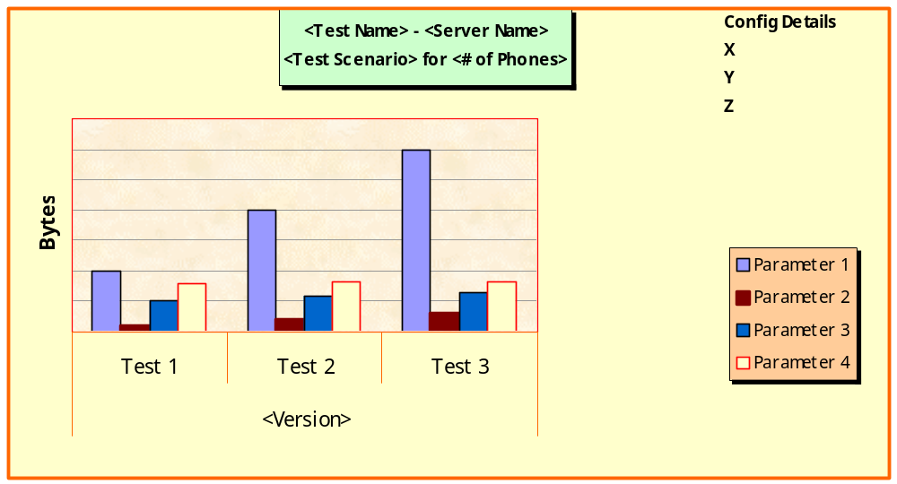

Conclusion
The above Profiling framework has been adopted for our effort and it has helped produce increased performance on the MCS servers across releases.

“ System Testing is both the most misunderstood and most difficult testing process ” – Glenford J. Myers

