Introduction

In this new series of articles, the building blocks of the newest (and most impactful!) measurement process is illustrated. The measurement process is based on the ISO/IEC 15939, Software Measurement Process standard, currently in the final stages of becoming an international standard. This article introduces the measurement process and provides an overview of the “building blocks”. The next six articles in this series will address each major activity and process element, including
- Determining Information Needs
- Establishing the commitment and resources for the measurement process
- Planning the measurement process
- Performing the measurement process
- Evaluating the measurement process
- Measurement and analysis data store
- Measurement experience base

Overview of ISO/IEC 15939, Software Measurement Process

The International Organization of Standards (ISO) Subcommittee on Software Engineering (SC/7) is the developer of a measurement standard, titled “ISO/IEC 15939 – Information Technology – Software Engineering – Software Measurement Process.” From the ISO/IEC 15939 standard, the primary goal of the document is to “… identify the activities and tasks that are necessary to successfully identify, define, select, apply, and improve software measurement within an overall project or organizational measurement structure.”

While the title of this standard contains the word “software” (twice), the standards should not be ignored by the systems engineering community. The SC/7 subcommittee develops both software and systems engineering products, and is in the process of formally broadening its scope to recognize its contribution to systems engineering. In addition, the ISO/IEC 15939 document does not contain any process elements that are unique to software engineering. It was the intent of ISO to apply the standard to systems engineering – only the name remains to be changed.

The purpose of this standard is to ensure that an organization performs the following measurement-related actions:
- organizational commitment for measurement will be established and sustained;
- the information needs of technical and management processes will be identified;
- an appropriate set of measures, driven by the information needs will be identified and/or developed;
- measurement activities will be identified;
- identified measurement activities will be planned;
- the required data will be collected, stored, analyzed, and the results interpreted;
- information products will be used to support decisions and provide an objective basis for communication;
- the measurement process and measures will be evaluated;
- improvements will be communicated to the measurement process owner.

This ISO standard describes the organizational elements required to support a measurement process. ISO/IEC 15939 organizes measurement into four primary measurement activities, establish capability, plan measurement, perform the measurement process, and evaluate measurement. The four activities are depicted in Figure 2: ISO/IEC 15939 Measurement Process , along with the external users and information needs to form the basis of “requirements” for the measurement process. In the standard, the four activities are decomposed into tasks, with tasks descriptions containing more detailed information on what it required to comply with the standard.

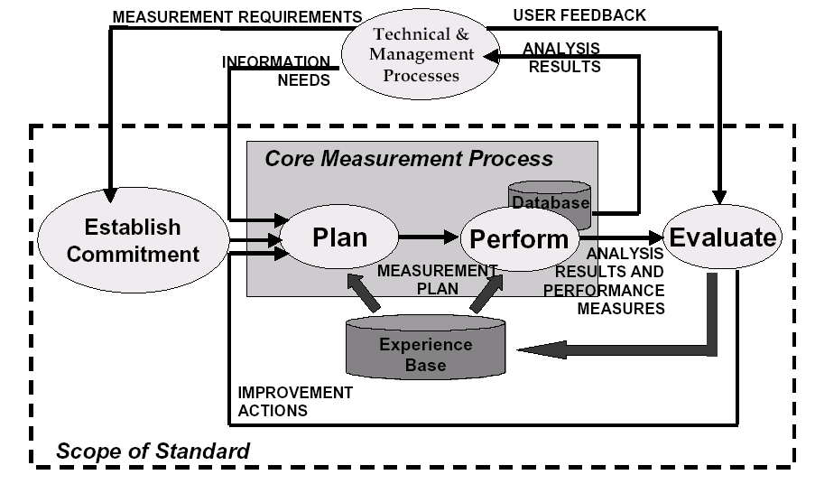
Figure 2: ISO/IEC 15939 Measurement Process

This standard defines measurement in two primary parts: a process model, as well as an information model. The process model depicts the relationship of activities and tasks. The information model describes the relationship of the measurement entities, in particular, a concise vocabulary for describing the elements commonly found in a measurement process.

A key point of terminology: The word “metric” is not found in the standard, and has been replaced by “measure”. The subcommittee found that no consistent or agreeable definition of the word “metric” could be found, and, hence, it was desirable to use a more appropriate, less vague, word than to attempt to correct decades of misuse.

If your organization or company is an ISO member, you can obtain a copy of ISO/IEC 15939 by contacting your organization’s ISO representative. The standard is a digestible 40 pages, of which 19 pages is informative appendices. The document is presently in the Final Draft International Standard stage, the last version before a Draft International Standard is balloted and becomes an international standard. The completion of the standards process, and release of final standard, is anticipated within the next 12 months.

Summary

This article provides the background for understanding an applying the measurement process described in ISO/IEC 15939. The next articles in this set provided detailed information about each major activity and process element in the model.

