Estimate Professional version 3.0
Product Review
James T. Heires

“Let’s play a little game,” your boss says to you. “I’m thinking of a number -- if you can guess the number, you get to keep your job. Let me know your answer tomorrow morning, so I can give the customer our software proposal.”
This might sound like an amusing contest, but you are the lead software engineer on this project, your job is on the line -- and you don’t have a clue about how to start!
You need the help of an estimation model. Estimation models help illustrate the cost, scope and schedule tradeoffs for a development project in a probabilistic way. At most only two of these variables can be constrained however -- the third must float (see Figure 1). In the game of estimation (as in the game of life) one cannot have their cake and eat it too.

Figure 1 - Pick any two!
Schedule
Scope
Cost
An estimate is normally produced as a response to a customer request prior to commitment, but is also helpful while the project is underway. Estimation models produce a forecast of duration, cost and staffing for a project.
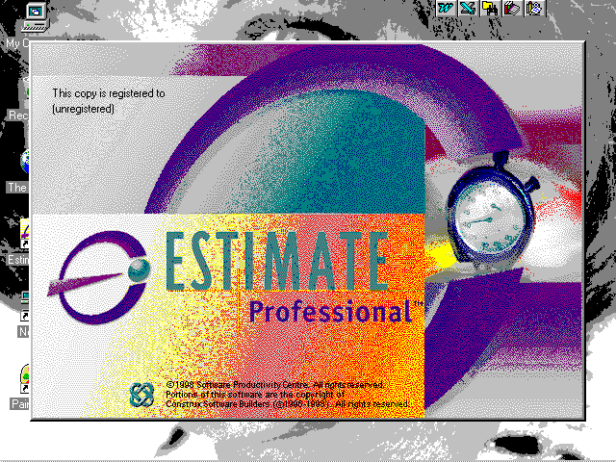
Estimate Professional (from the Software Productivity Centre) is a software estimation model designed for the occasional user. Unfortunately, complex tools such as this one require more assistance for the user.

Modeling ensures repeat business
Modeling allows a company to be much more confident when negotiating with its customers. This means better performance to commitments and stronger customer relations. Two risks of not modeling are under-bidding (leaving money on the negotiating table) and lowering your profit, and over-bidding and losing the contact.
Bottom line: rigorous estimation is a competitive advantage.

A Simple Example
The easiest way to produce an estimate is to use Estimate Pro’s wizard. The output is nominally based upon industry average productivity drivers (discussed later). These drivers can be optimized to an organization’s own development environment as information becomes available. Because information becomes known progressively, estimation is most effectively performed in an iterative fashion.
The model’s default output is a 50% probability estimate. That is, the probability of overrunning the estimate is 50% and the probability of underrunning the estimate is also 50%. The model also produces estimates at other probability levels so that users can select their own confidence threshold.
The estimate wizard prompts you for the following information:
- Project Name | - Start date
- Project Type, Subtype | - Size
- Phase name | - Language

Once the minimum inputs have been entered, the resulting estimate is shown in the Estimate Summary View (see Figure 2).
The left-hand portion of the estimate summary view includes the project scope (size), the nominal plan and the optimum plan. The nominal plan is defined as all priorities equally weighted, whereas the user sets the priorities of the optimal plan. At this point, the nominal and optimal plans are the same, since project priorities have not yet been selected. This 65KSLOC project has a 50% probability of taking 15 calendar months, 67 staff-months of effort and 6 people maximum.
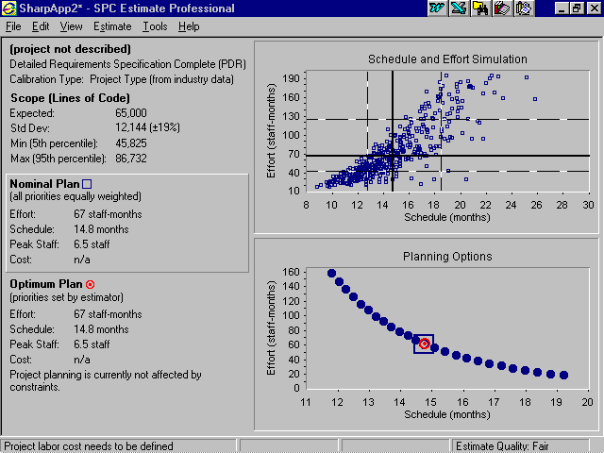
Figure 2 - Estimate Summary View
On the right side of the estimate summary view are two graphs. The top graph is a depiction of the effort and schedule combinations of hundreds of “projects” created with a Monte Carlo simulation. These “projects” are fabricated by varying the size, productivity, staffing levels and other input variables to produce a range of possible effort and schedule solutions. Solid lines on the graph represent the median effort and schedule values, while the dashed lines represent the 25th and 75th percentile outcomes. This helps to illustrate the probabilistic nature of estimation.
The bottom graph (Planning Options) shows the schedule and effort tradeoffs available. The 50% probability solution (nominal plan) is indicated by a square, while a circle indicates the optimal solution.

Refine the estimate for more precision
Real projects have deadlines and budgets, so now it’s time to model the project constraints and priorities. Entering a schedule constraint of 12 months and a high schedule priority causes the model to recalculate the optimum plan in order to shorten the schedule. The graphs now show the schedule constraint as a white boundary (see Figure 3). The optimum plan now shows that the project will take 12 calendar months, 164 staff-months of effort and a maximum of 20 people.
Using Estimate Professional, it is easy to show your boss the penalties for compressing the schedule!
Calibration
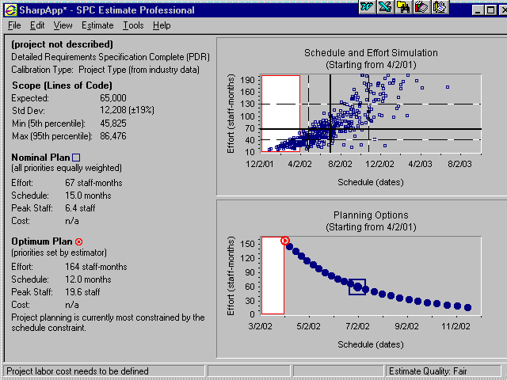
So far, this estimate has been produced using data from industry average projects of the same type. Estimate Pro, however, can be calibrated by using information about an organization’s project environment and historical data from actual project performance (preferred). The project environment is calibrated using Productivity Drivers, which consist of a list of personnel, project and product attributes. Historical data is a bit more detailed, but allows a much better calibration of the model. However, Estimate Pro only uses this historical data internally to calibrate the model. It would be more beneficial if it were graphically compared to the current solution to be used as a visual sanity check as well.
Figure 3 - Optimized solution

Show me the money
To calculate project costs, hourly rates are entered. Specify either general hourly rates or detailed rates by job type. Total project cost figures are calculated and shown in both the nominal and optimal solutions.

Would Lines of Code by any other name smell as sweet?
Sizing can be expressed in various ways with Estimate Pro. In addition to lines of code, Graphical User Interface (GUI) components accumulate the number of dialog boxes, windows, files and external interfaces. The Function Point option expresses size using the 1984 IBM method, which is essentially the current practice of the International Function Point User Group (IFPUG). In any case, the resultant sizing measure is expressed as lines of code.

Reports
The reporting function is satisfactory, but somewhat inflexible. There are 22 prewritten reports and three different graphs, which appear in the Estimate Pro output. Probability tables, a cash flow projection and a trade study analysis highlight the available reports. The reports are well written but there is no way to change the content of the output (other than the title page) or to export the reports to a word processor. Zooming and printing are the only options here.

Summary
Estimate Professional fills the need for an approachable software modeling tool. However, more assistance (e.g., context-sensitive help and documentation) is needed for the occasional user. Since project type partially determines the estimate outcome, better definitions are needed to assist the user.
Hard copy documentation is terse and over-simplified, considering the impact an incorrect estimate could have. The help system is better than the documentation but still a little weak, even considering the excerpt from Steven McConnell’s book.
Future versions of Estimate Pro should include a forecast of field defects or reliability. In addition historical data points should be visible on the solution graphs. A user-selectable solution probability (other than the default 50%) would also be helpful.
Even with these shortcomings, Estimate Professional is a viable low-cost alternative. Training and technical support is available through the Software Productivity Centre.

System Requirements
PC with a 486 or later processor
Windows 95 or NT 4.0
12 MB Hard disk space
Access to a CD-ROM drive.

Pricing
Estimate Pro is priced at $695 for a single user license. Multiple user licenses are also available at a higher price point.

Software Productivity Centre Inc.
Suite 460 - 1122 Mainland Street
Vancouver, BC, Canada V6B 5L1
(604) 662-8181 extension 300
email: tools@spc.ca
web: www.spc.ca

About the author
James Heires is a 12-year veteran of the software industry, primarily at a Fortune-100 aviation electronics company located in the Midwest. His current professional interest lies in project cost estimation based on the analysis and use of historical project data.

Complaints from version 3.0
- (minor) Minimal help when using estimate wizard (to assist with type/subtype definitions).
- (minor) Small (e.g., <500 SLOC) projects not supported. Check into automatic “Small Project Mode” and indicator as mentioned in help files.
- (minor) Save As does not allow the user to browse for a directory to store you files into. Where is it storing my files?
- (major) Setting productivity drivers causes the optimum solution to go away (all values are “N/A”). A message “Project planning is currently overconstrained by the schedule constraint” appears in the optimum solution panel and “Overconstrained” appears in the status bar at the bottom of the screen. Why did the optimum solution become overconstrained simply by entering productivity drivers? This behavior is counter-intuitive, since the productivity drivers seem to indicate that the project is better suited to meet its 12-month schedule constraint, not worse.
- (minor) Does the estimate quality rating have any logic or algorithm associated with it? It seems to be connected to weather or not productivity drivers forms were completed.
- (minor) I wish there were a “reset” button on the Calibrate Productivity dialog box, which would set all variables to their nominal values.
- (minor) The recalculation is agonizingly slow on my 486 laptop.
- (clarification) Exactly which function point standard is followed? In the help files, the 1984 IBM method was cited, but no IFPUG version.

Complaints from version 2.0
- (major) Clicking on the Calibration Type section (left side of summary view) and then What-If, causes the software to lock up. Not any more...
- (major) Basic Scope Estimate dialog does not work correctly. Entering low, expected, high SLOC data of 40,000 50,000 and 60,000 respectively generated an error message: “Values entered are too large.” However, deleting either the low or the high value works as expected. Not any more...
- (nuisance) Open Existing Estimate needs to be selected before an estimate appears in the list. Selecting an estimate in the list should, instead, automatically change the option to Open Existing Estimate. Not any more...
- (minor) Selecting Cancel at the estimate wizard dialog box exits the program. I expected to be able to start a new estimate. Not any more...
- (minor) The recalculation is agonizingly slow.

Jones, Capers. Applied Software Measurement: Assuring Productivity and Quality. New York: McGraw-Hill, 1991.
McConnell, Steven. Rapid Development, Microsoft Press, 1996

