GD Pro 3.1

Product Review
James T. Heires
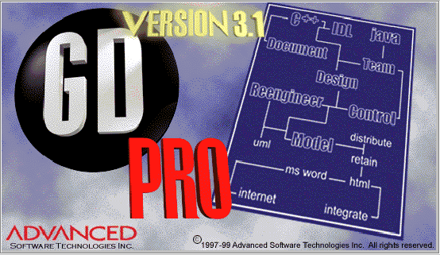
Version 3.1 from Advanced Software Technologies, Inc.

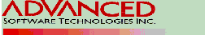

Applying the Unified Modeling Language (UML) is now easier, thanks to GD Pro 3.1. The visual modeling tool offered by Advanced Software Technologies supports software design, development, redesign and maintenance for small and large teams alike.

GD Pro supports the UML version 1.1 more completely and consistently than any other modeling tool. The easy-to-use graphical interface employs familiar Microsoft Windows® paradigms. Java, C++ and IDL code generation is straightforward, surprisingly insightful and avoids code markers, which can make maintenance and readability difficult. Reports generated by GD Pro are simple to produce and quite useful, especially in collaborative team environments where clear, accurate communication between geographically disperse team members is key. In addition, GD Pro integrates with many popular companion tools such as DOORS, Visual Studio, Word, Netscape Navigator, Rogue Wave and Visible, to name a few.

If all this sounds too good to be true, hold on – GD Pro has its share of shortcomings as well. One big omission: There is no Undo command. The Undo command has become an indispensable part of today’s commercial products – no viable tool developer should go to press without it. Second, the product does not run under some versions of Windows 95 out of the box. Downloading a file (DCOM95.EXE) from the Microsoft website (http://www.microsoft.com/com/dcom/dcom95/download.asp) fixes the problem, but this is an unexpected annoyance sure to alienate some users. Advanced Software has promised to correct both of these oversights in future versions of GD Pro. In fact, by the time you read this, GD Pro’s next version will have shipped with a multiple undo/redo stack, as well as a number of other improvements.

My overall impression of GD Pro version 3.1 is favorable. One reason is because its maker is actively taking steps to correct the shortcomings identified here for future versions of the product.

GD Pro supports visual modeling more completely.
The UML has been around since 1995, yet GD Pro is the first and only visual modeling tool which supports all eight diagrams and even manages to extend the language. This is something that even Rational Software (the company whose chief scientist is a principle author of the UML) cannot claim about their Rose 98 offering.

The UML extension implemented in GD Pro is called the package diagram. The package diagram is intended to communicate how the system functionality is divided into source files, and how source files depend upon each other.

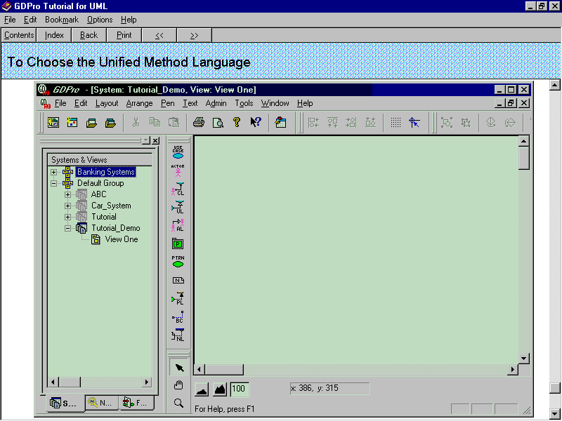
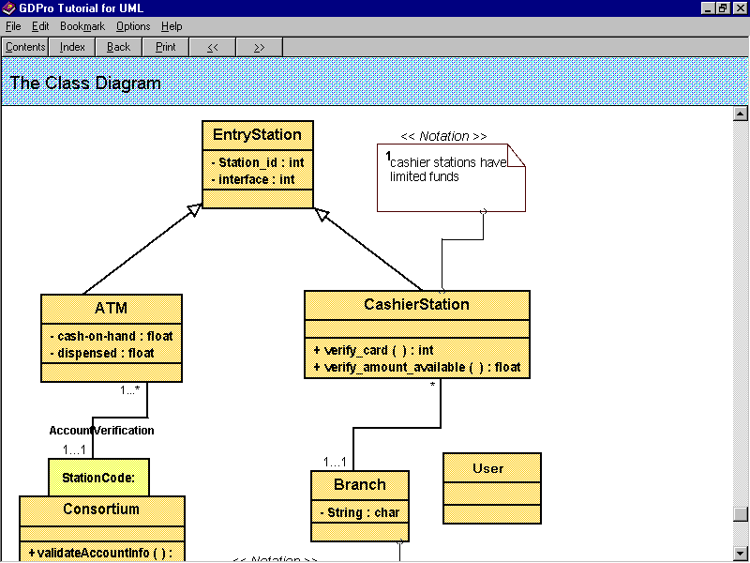
GD Pro's user interface is clear, concise and non-intrusive (see Figure 1). On the left is a Systems & Views browser for navigating through diagrams. On the right is a workspace for creating and viewing diagrams. Between the two portions of the screen is a floating tool bar, the function of which changes according to the active diagram type. The only trouble with the user interface is that opening a system to see what diagrams it contains is unexpectedly s-l-o-w. It turns out that opening a system causes GD Pro to compile a series of scripts, needed to allow the use of multiple modeling approaches. It occurs to me that these scripts could instead be compiled only when the user indicates that multiple approaches are desired. Advanced Software has made performance enhancements to address this issue for their next version.
Figure 1 - GD Pro user interface

The user interface can be shared with a team by using GD Pro's collaborative white board capability. This feature allows a distributed team to work together on a diagram or system over the internet, while maintaining strict CM control over the diagrams and source code.

Code Generation with marker-less round-trip engineering
GD Pro generates and reverse engineers marker-free code in C++, Java and IDL languages. One of GD Pro’s most widely publicized features is that code markers are never needed.

Markers are used by other modeling tools to keep the code in sync with the design model. Code markers are the proverbial breadcrumbs that lesser-informed tools employ to discern where they have tread. If code markers were accidentally deleted, however, the tools that use them would become lost. Reverse engineering legacy code (with no existing markers) can cause similar behavior in marker-dependent tools. The use of markers can cause the loss of comments, compiler directives and control code when reverse engineering and add significant bulk when generating code. In fact, code markers can add as much as 400% to the size of marker-less code. Because of all these potential problems, some tools force developers to use special marker-aware editors. Any developer will attest that a source code editor is a very personal thing, and it is not wise to force the use of a specific editor.

First time around (Code Generation)
Code shells are generated from the design information provided by the UML diagrams. The shells compile, but need to be supplemented with algorithms and logic to provide end-user functionality. When designing a system for the first time, if a class has been added, code generation creates header and body files. These files contain all the information captured during the design process that defines the class. I found the generated code to be quite insightful, readable and complete.

Next time around (Re-Engineering)
Re-engineering starts with an existing model and code, and modifies the model to reflect changes in design. Code generation then merges any changes to the design into the existing header and body files for the class. GD Pro does not, however, modify any code outside the header and body class definition sections. All changes to the old source code are noted in an automatically generated report. The re-engineering process also creates backup files for all source code it modifies.

Once more, only backwards (Reverse Engineering)
Reverse engineering is usually performed to better understand an existing body of code before a redesign or maintenance activity begins. This analysis is similar to the re-engineering scenario above, except GD Pro starts by analyzing the code, then generates a UML model. Both a class diagram and an implementation diagram are produced from the existing code.

Reports
After a system has been designed, generating reports in a variety of formats is easy. File formats including ASCII, HTML and RTF are available. The report set includes Data Dictionary and Object Model Reports that permit rapid navigation through the class structure, and are linked directly to the source code and UML diagrams. This “live” report feature is particularly helpful in a collaborative work setting.

There are defects in the report feature, however. HTML reports I generated (such as the Class Model Report) had broken links because code had not yet been generated. Links pointing to code should be suppressed if no code has been generated. This defect was found using Netscape Navigator, although I am told that it is not exhibited using Internet Explorer. Likewise, Rich-Text Format (RTF) reports also contained erroneous links.

Conclusions
Advanced Software Technologies has done application developers a great service with GD Pro. More improvements are certain for future releases, but even this release contains considerable value. Looking beyond the installation problems, lack of an undo feature and report snafu, GD Pro is a strong contender in the visual modeling tool arena.

Price/availability:
Win95/NT: $2495 (one floating license)
UNIX: $3995 (one floating license)
Volume pricing is also available.

GD Pro is available from Advanced Software Technologies, Inc.,
7851 South Elati Street, Suite 102
Littleton, CO 80120
(303) 730-7981
1-800-811-2784
Email: info@advancedsw.com
Internet: www.advancedsw.com

“The Unified Method,” Draft edition (0.8), Rational Software Corporation, October 1995.
"Rational Rose 98 Enterprise Edition," Application Development Trends, November, 1998

